1.Write a c program to check whether the given number is even or odd.
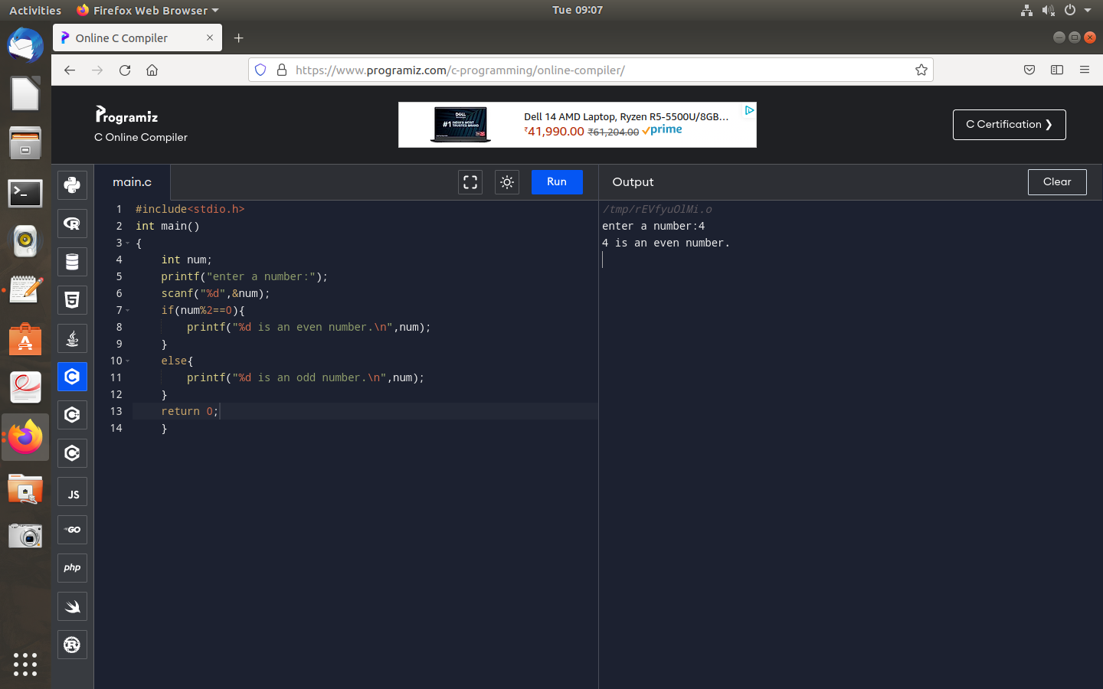

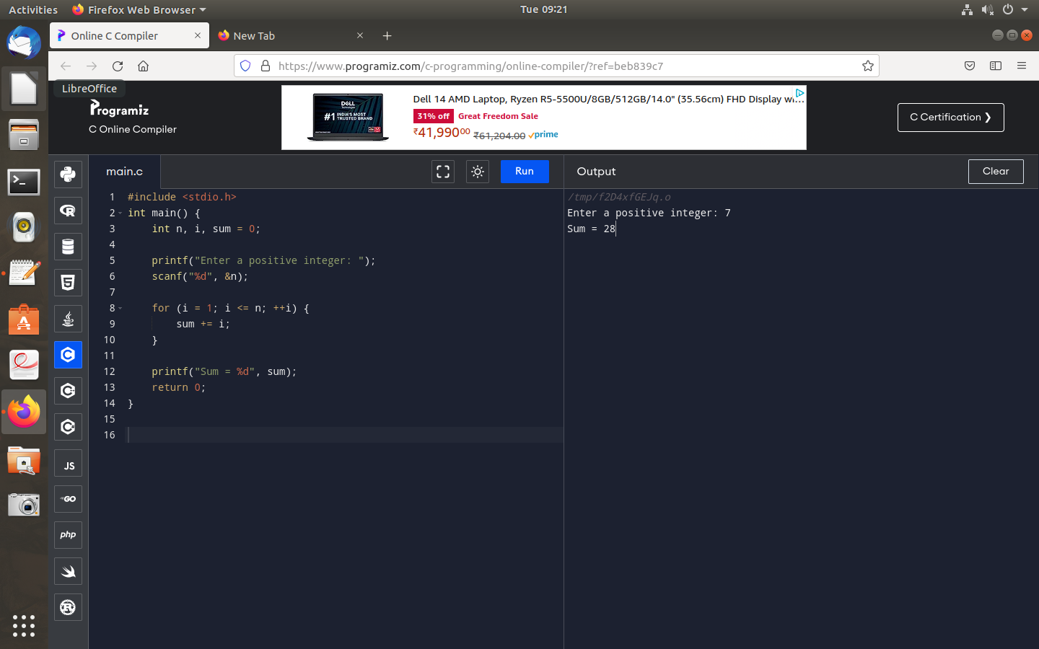
2.Write a c program to find the sum of first n numbers using for loop.

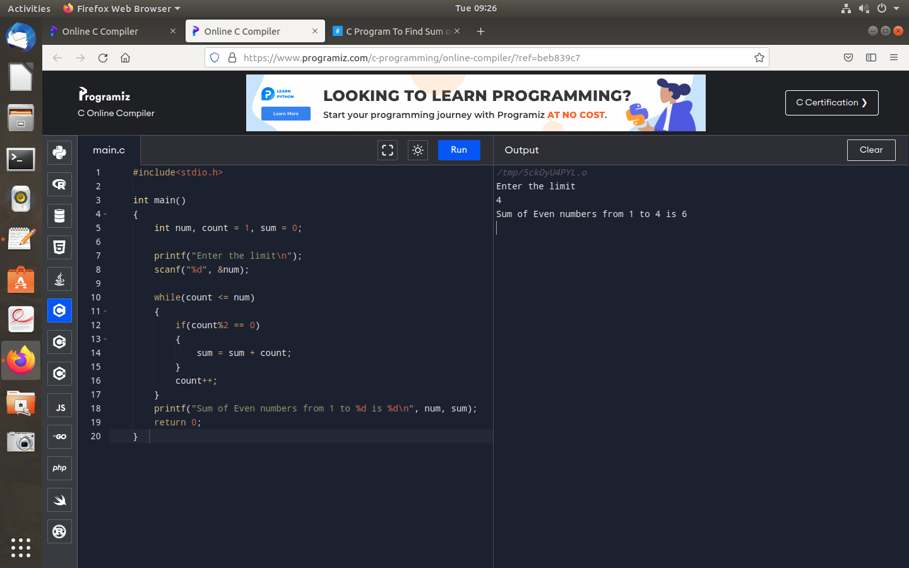
3.Write a c program to find sum of even numbers using while loop.

4.Write a c program to reverse a given number.
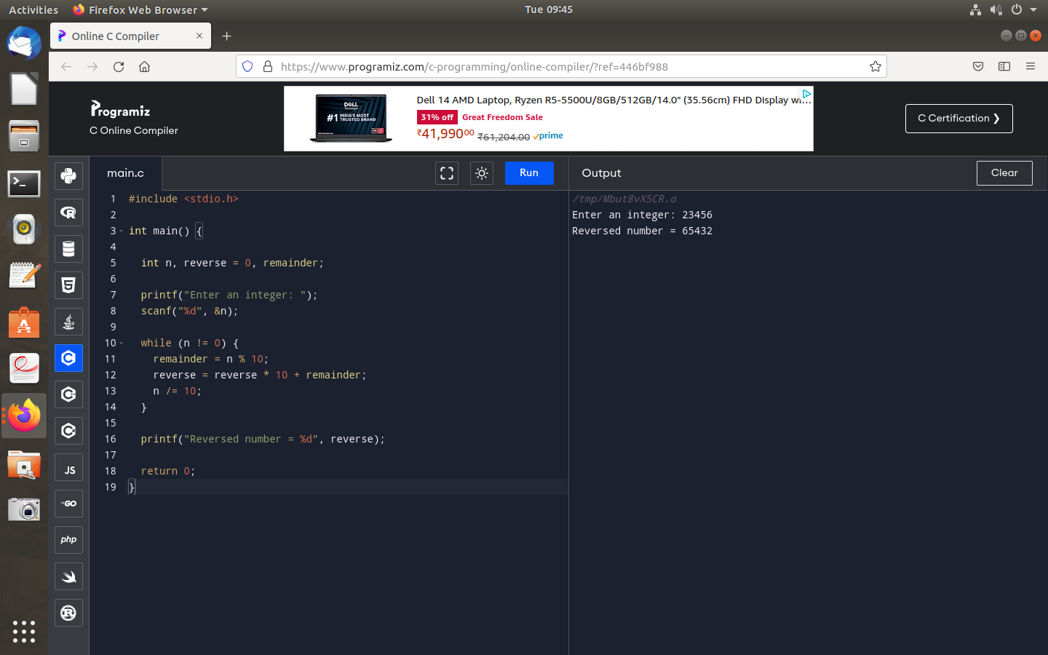

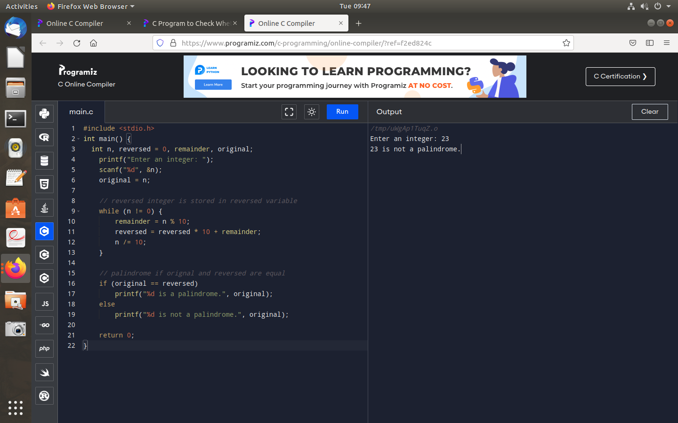
5.Write a c program to check the given number is palindrome or not.

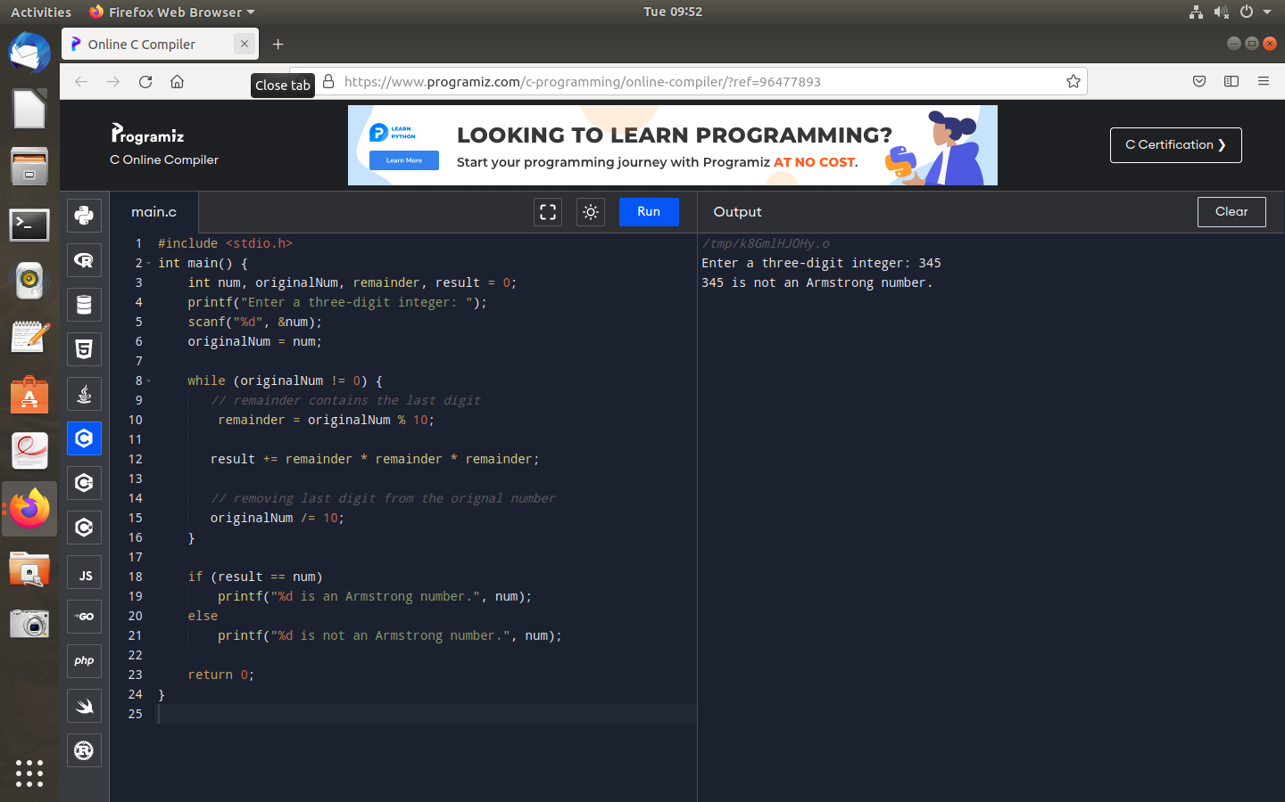
6.Write a c program to check the given number is armstrong or not.

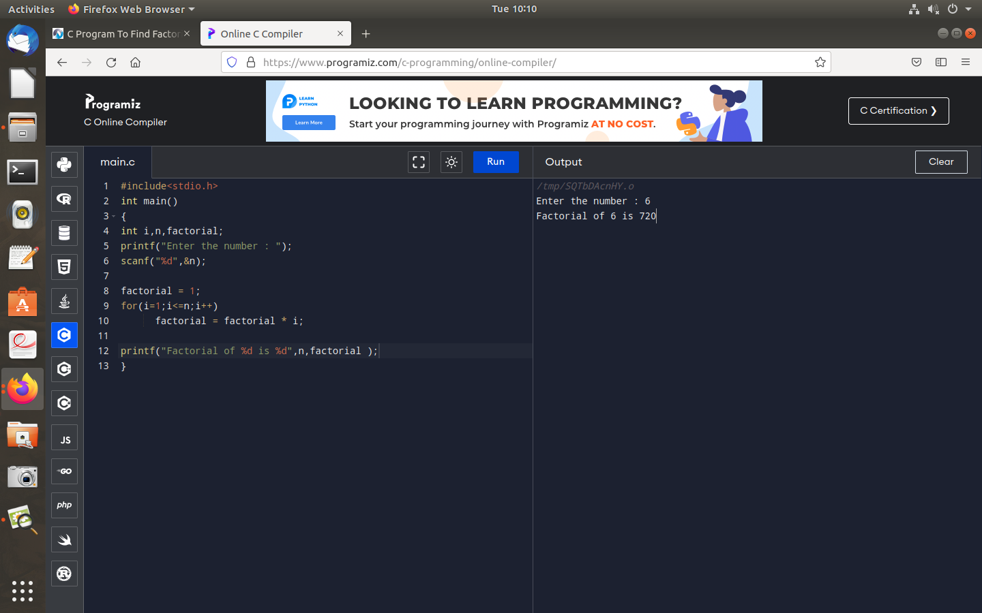
7.Write a c program to find factorial of a number without recursion.

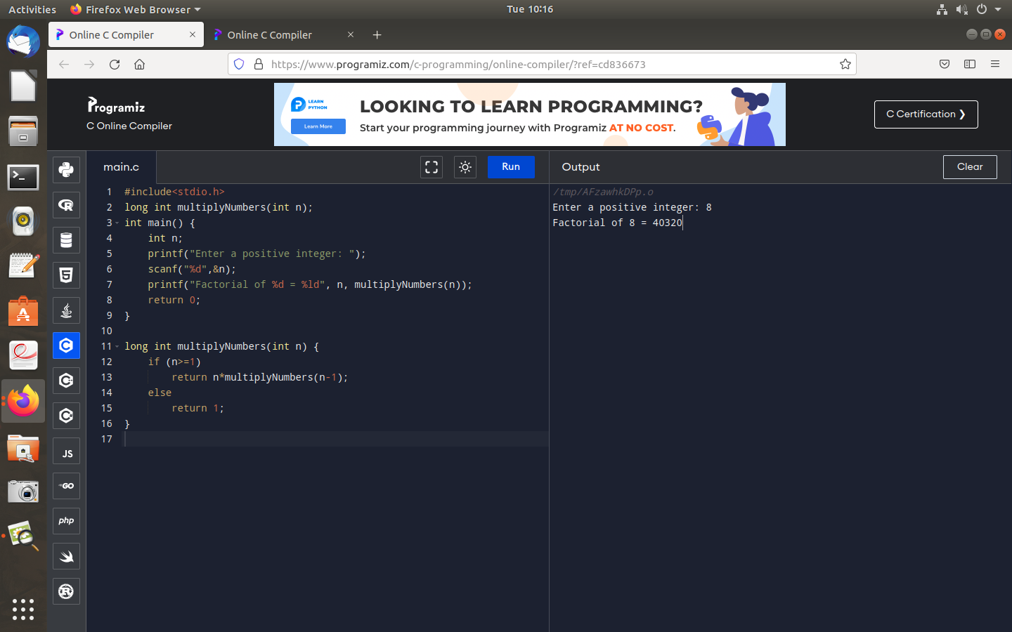
8.Write a c program to find factoroial of a number with recursion.

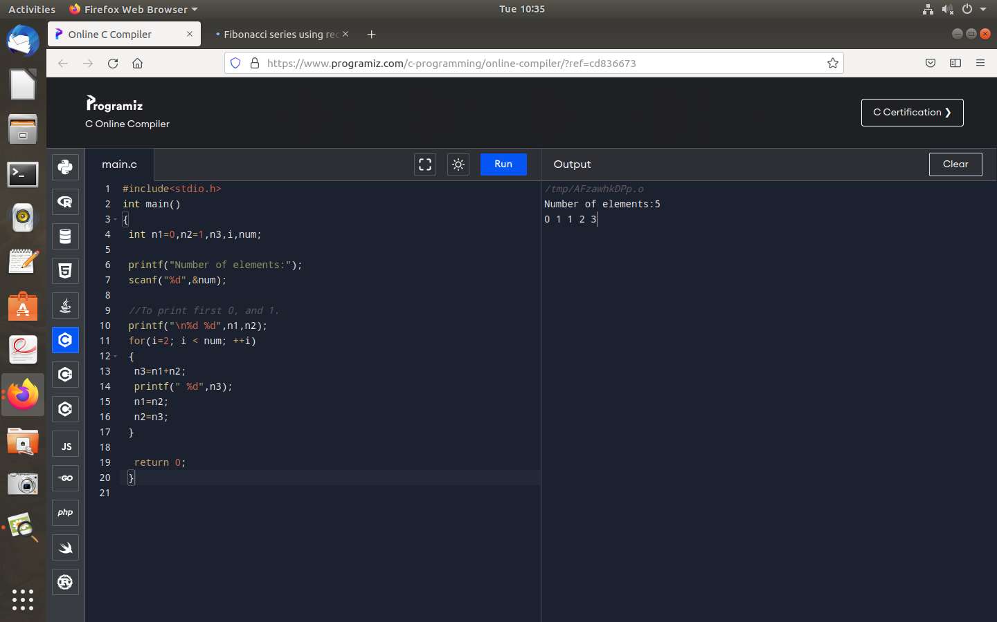
9.Write a c program to generate fibonacci series without recursion.

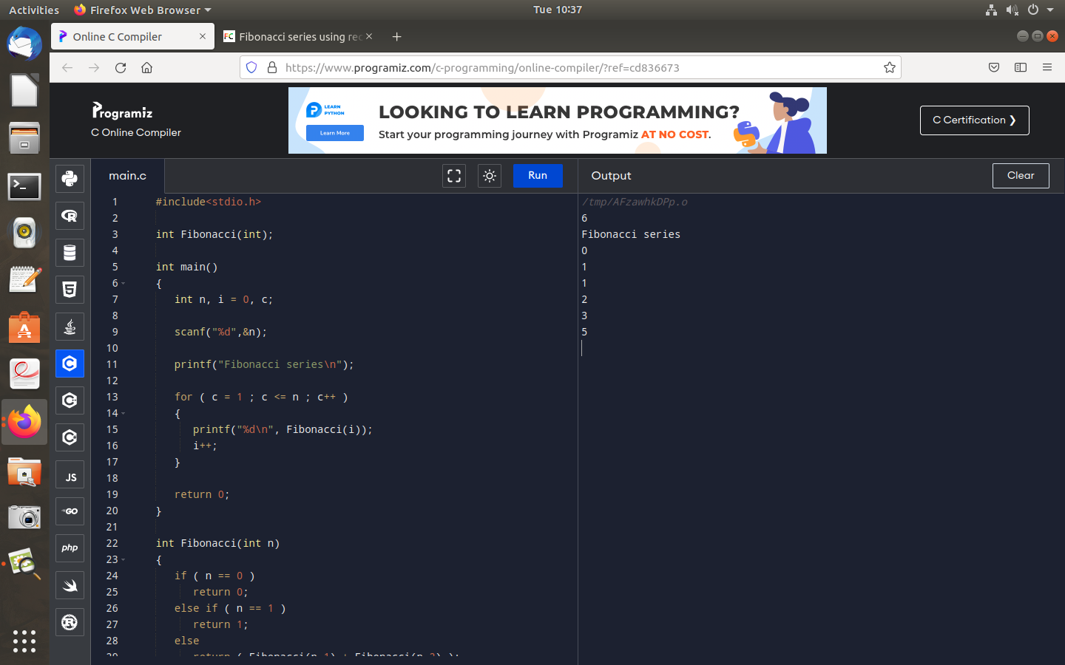
10.Write a c program to generate fibonacci series with recursion.

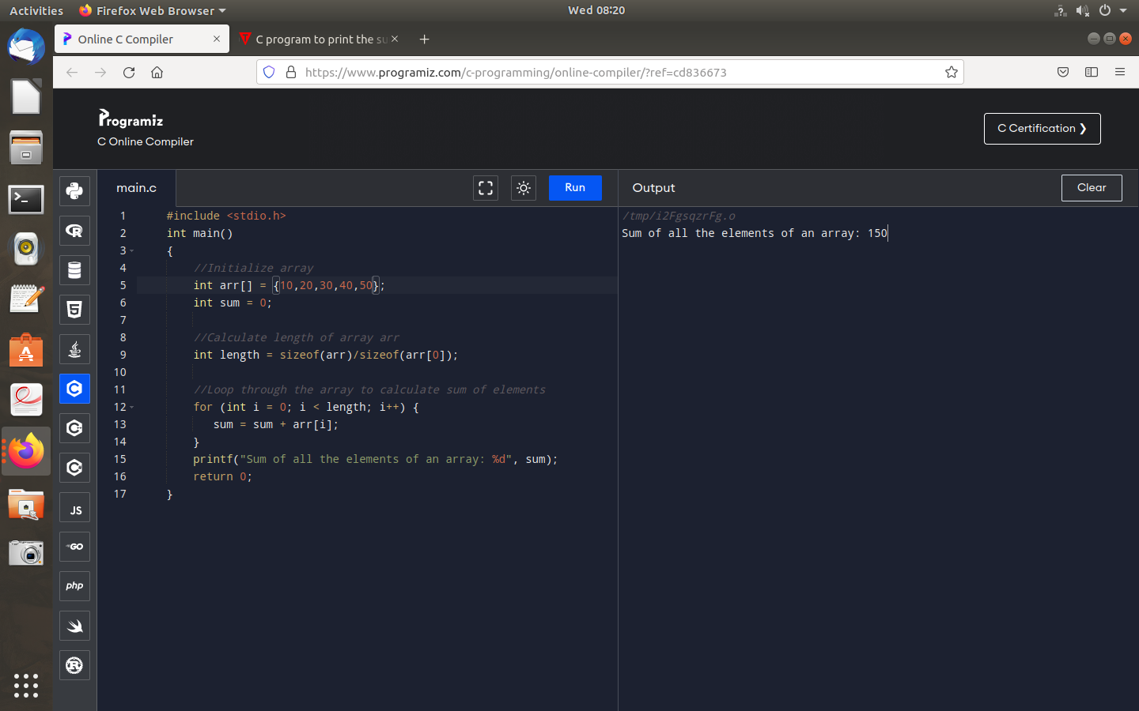
11.Write a c program to calculate the sum of elements in an array.

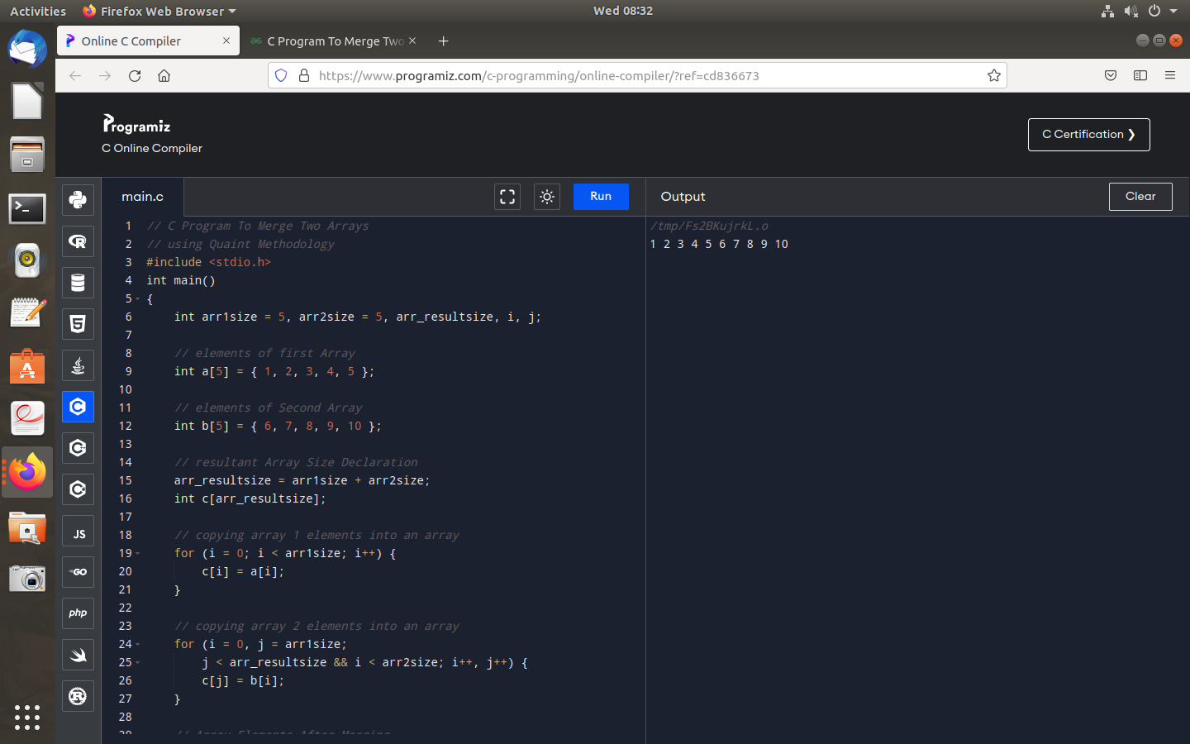
12.Write a c program to merge two arrays.

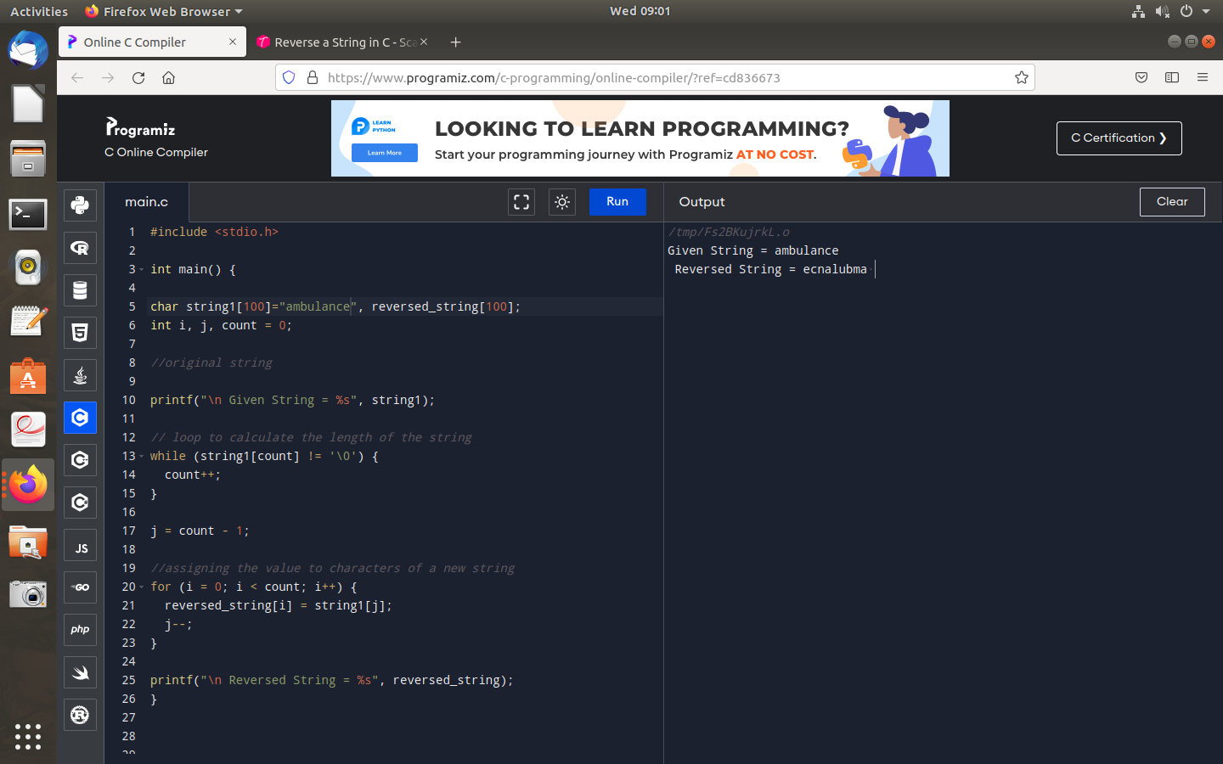
13.Write a c program to reverse a string.

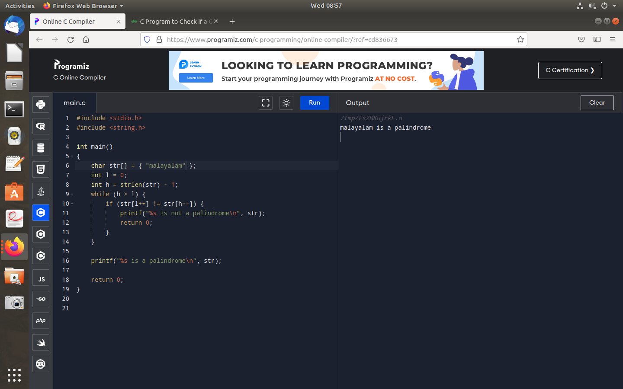
14.Write a c program to check the given string is palindrome or not.

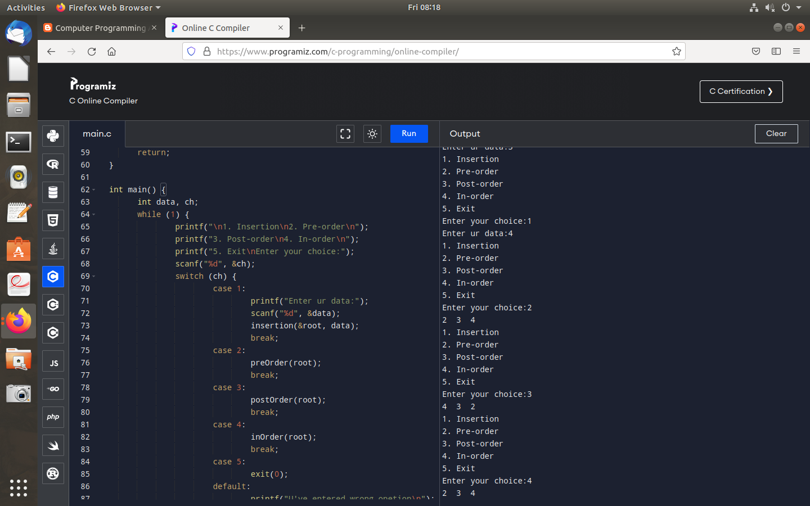
15.Write a c program to implement binary tree traversals.

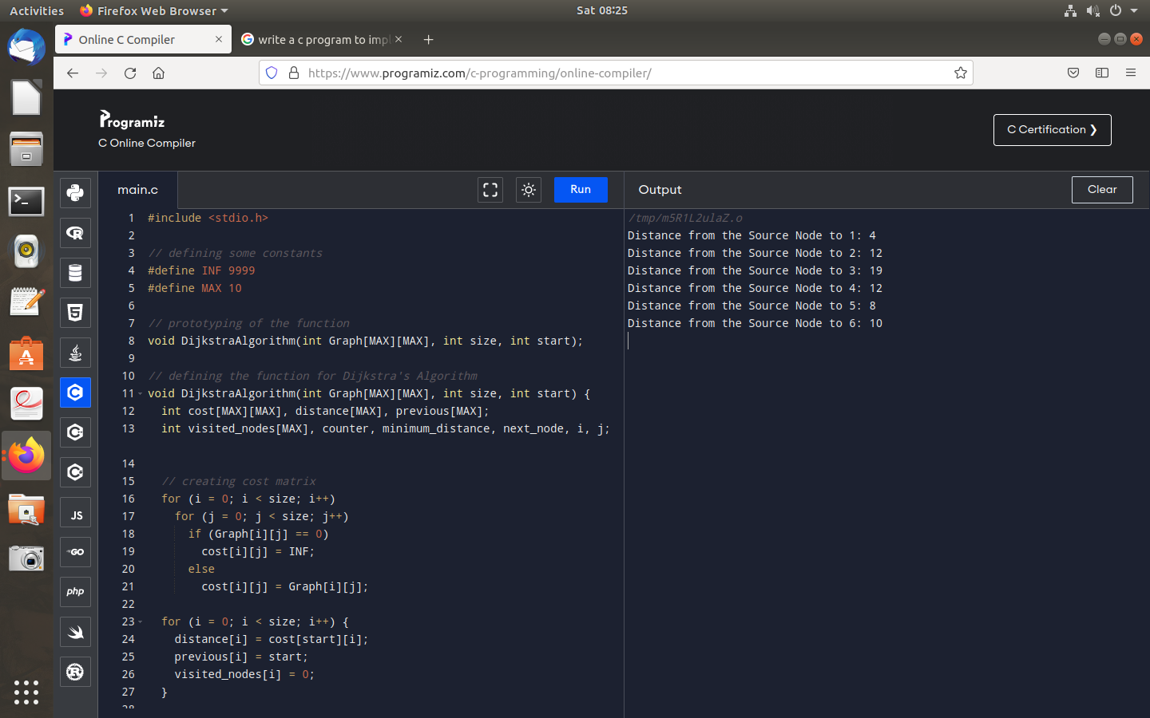
16.Write a c program to implement single source shortest path technique.

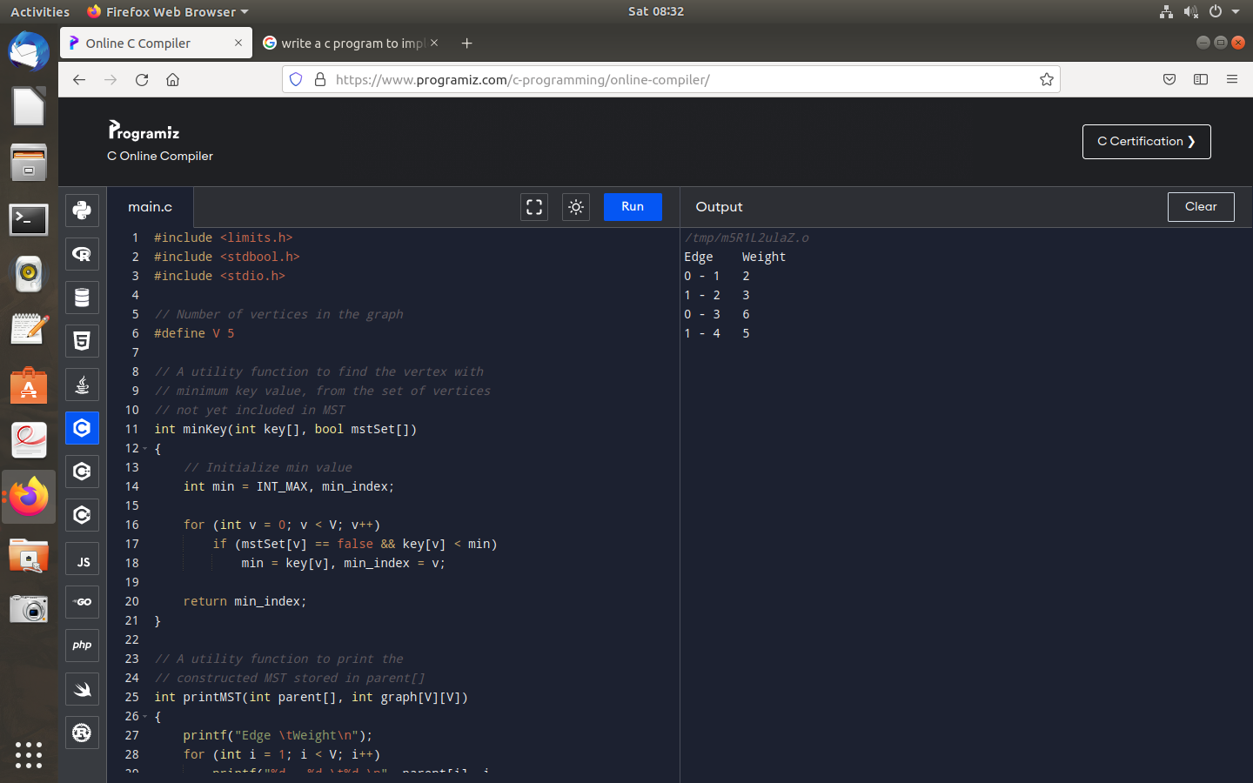
17.Write a c program to implent minimum spanning tree using prims algorithm.

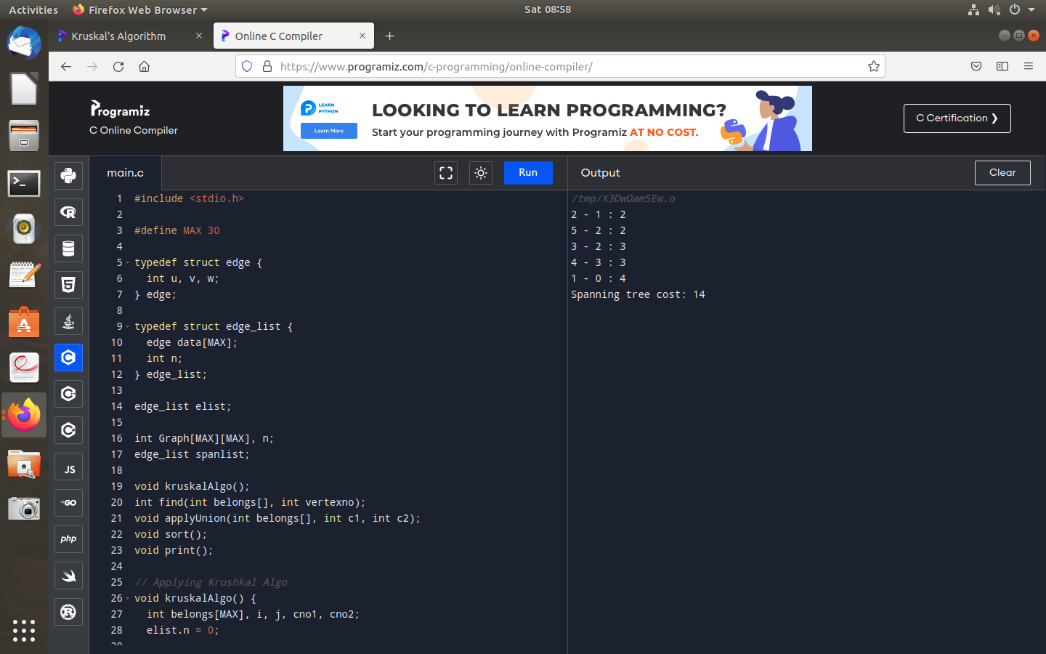
18.Write a c program to impement minimum spanning tree using krushkal algoritthm.

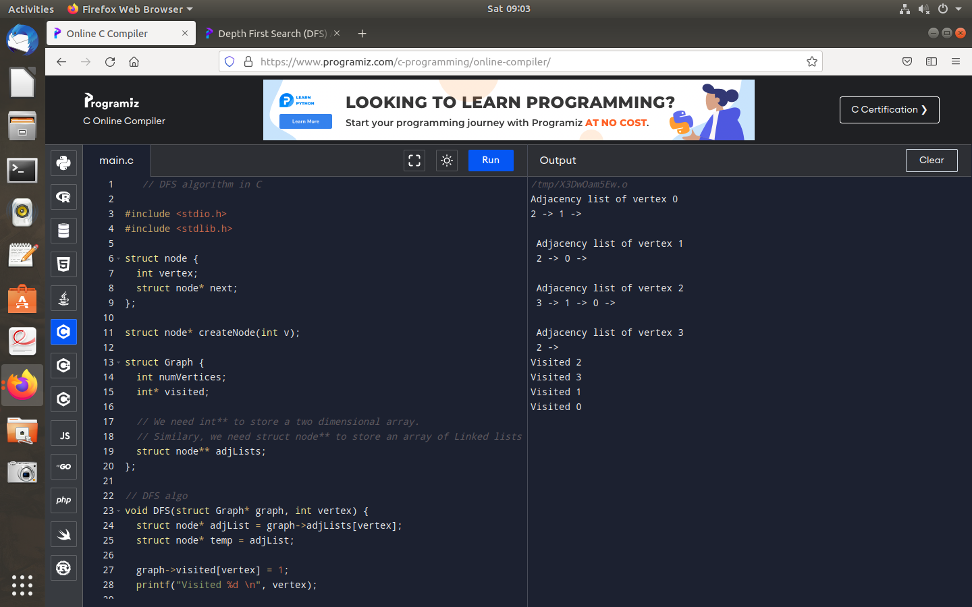
19.Write a c program to implement depth first search graph traversal.

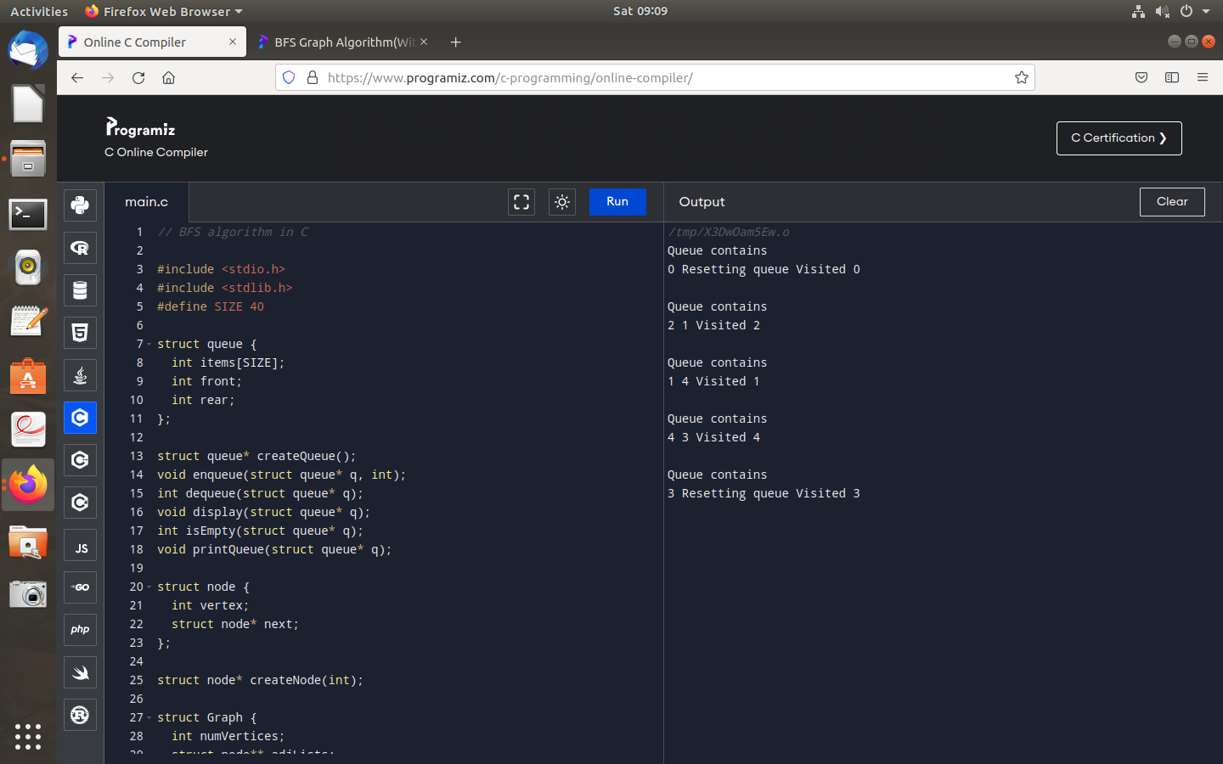
20.Write a c program to implement breadth first search graph traversal.

